Development and Characterization of Textile-Electrode Electroencephalogram Systems for Brain-Computer Interfaces

The objective of this thesis is to advance the development of a wearable electroencephalography (EEG) system using textile-based electrodes for signal acquisition over hair-covered regions and regions where the skin is exposed directly. The project encompasses both hardware and software development, with a focus on prototyping pre-amplifier circuits for textile electrodes and designing computational methods for processing these recorded textile-based EEG signals.

A pre-amplifier circuit will be prototyped and tested to specifically improve signal acquisition from textile electrodes. Afterwards, digital signal processing methods will be implemented to filter and enhance textile-based EEG signals. Models will be developed to mitigate noise, improve signal-to-noise ratio, and optimize classification performance in brain-computer interface (BCI) applications. The combined hardware and software system’s performance will be characterized and benchmarked against gold-standard clinical EEG electrodes in both simple experimental paradigms and established BCI tasks.

This study aims to demonstrate the technical feasibility of textile-based EEG for wearable BCI applications and its research outcomes are expected to contribute both to academic knowledge and to potential commercialization efforts in collaboration with industry partners. Findings will support the preparation of a publication detailing textile electrode validation, EEG signal amplifier design, and software-based signal filtering, with future applications extending toward wearable BCI systems and clinical use cases.

Folder Structure

- Code/
  - Contains a Python script for XDF processing and plotting, along with coding requirements.

- Data/
  - Recorded raw EEG datasets for analysis.
  - Contains .xdf`sessions and organized by different recording dates and devices.

- Documents/
  - Includes thesis documents and presentation assets.

- Enclosure Design/
  - Mechanical design files for the printed circuit board enclosure.
  - Contains Autodesk Fusion 360 files, various computer-aided design exports, model renders, and 3D printing code.

- Papers/
  - Reference literature and research papers relevant to the textile project.

- Printed Circuit Boards/
  - Hardware design files and manufacturing assets.
  - Contains KiCad projects, custom symbols/footprints/3D models, old design iterations, and production files.

- Results/
  - Plot generated from the XDF analysis script.
  - Organized between testing methodologies for all figures and derived data.

Design Sourcing

Software:
- Mechanical Design
  - Autodesk Fusion 360
  - BambuStudio
- Electrical Design
  - KiCad

Hardware:
- Enclosure Assembly
  - PLA filament printed using a Bambu Lab A1 printer
  - Snap buttons taken from these connectors in the Rapid Prototyping Hub’s electronic cabinet
    - 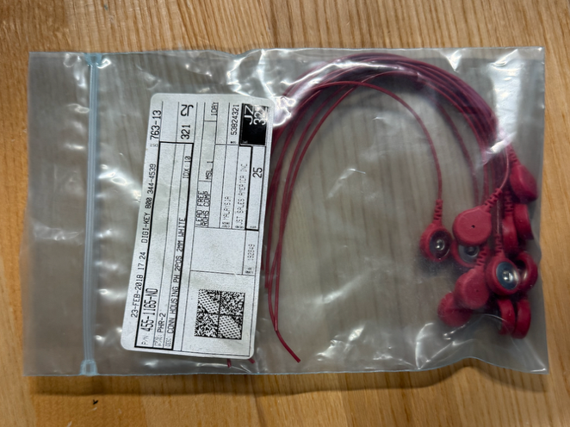
    - The female snap button needs to be ripped out of this component
- Circuit Testing
  - All electrical components sources from the Rapid Prototyping Hub
    - Specifically used the AD706 operational amplifier
  - Breadboard, oscilloscope, voltmeter, and other testing devices sourced from the Rapid Prototyping Hub
- PCB Design
  - Manufactured using the PCB Assembly option with JLCPCB
  - Power and signal connections used stranded 32 AWG shielded wires found here:
    - https://www.digikey.ca/en/products/detail/tensility-international-corp/30-01432/13151730
  - Soldering completed at the University of Toronto; can also be completed in the Rapid Prototyping Hub

Contact

- UofT Email: danielz.yu@mail.utoronto.ca
- Personal Email: danielu6776@gmail.com

Feel free to contact me anytime! :)

